**Lab-5**

**Out Date:** 10/16/2018 (Tuesday)

**Due Date:** 10/16/2018 (Tuesday) within class time

**Problem-1 [80 points]:** Design a class that has an array of floating-point numbers. The constructor should accept an integer argument and dynamically allocate the array to hold that many numbers **[10 points]**. The destructor should free the memory held by the array **[10 points]**. In addition, there should be member functions to perform the following operations:

* Store a number in any element of the array **[15 points]**
* Retrieve a number from any element of the array **[15 points]**
* Return the average of all the numbers stored in the array **[20 points]**

Demonstrate the class in a program as shown below in a sample output **[10 points]**:

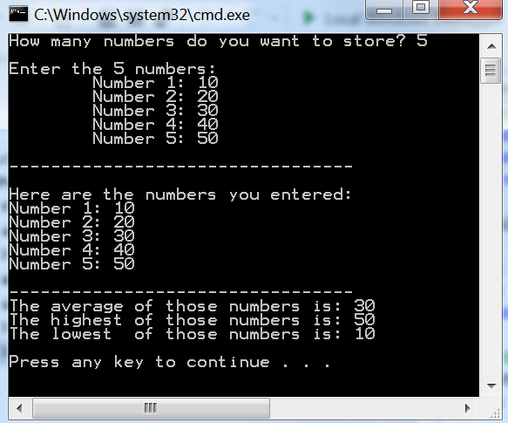

**Scoring Distribution [100 points]**

* 80 points for implementing the above mentioned requirements.
* 10 points for appropriate comments
* 10 points for programing style

**Blackboard Submission**

1. Show the working program to the instructor
2. Zip the file (**NumberArray.h, NumberArray.cpp, and Lab5.cpp**)
3. Upload it to blackboard